NS-3 installation & running scripts

[WAZID ULLAH MURAD](https://www.facebook.com/wazidullah.murad?eid=ARCAS-nnId0nUgBbl6vjcROBuyluFwCIFJ_n4lFBRuWXtZaz4hSh-IXgn13ecdP5ByQcqsHcQhOAS8FI)·[SATURDAY, FEBRUARY 22, 2020](https://www.facebook.com/notes/%E0%A6%85%E0%A6%A8%E0%A6%BF%E0%A6%B0%E0%A7%81%E0%A6%A6%E0%A7%8D%E0%A6%A7-%E0%A7%A7%E0%A7%A9-%E0%A6%AE%E0%A6%BE%E0%A6%AD%E0%A6%BE%E0%A6%AC%E0%A6%BF%E0%A6%AA%E0%A7%8D%E0%A6%B0%E0%A6%AC%E0%A6%BF/ns-3-installation-running-scripts/3661027883937988/)·

NS-3 is most preferable for Linux(Ubuntu/Mint).so, here’s the installation process for ubuntu/Mint is given.

**Step 1: installing libraries:**

open Terminal (ctrl+Alt+T) & run the following commands one after one. if it requires (Y/N) anytime, then simply write Y & press ‘Enter’ button.

sudo apt-get install gcc g++ python python3

sudo apt-get install gcc g++ python python3 python3-dev

sudo apt-get install python3-setuptools git mercurial

sudo apt-get install qt5-default mercurial

sudo apt-get install python-pygraphviz python-kiwi python-pygoocanvas libgoocanvas-dev ipython

sudo apt-get install gir1.2-goocanvas-2.0 python-gi python-gi-cairo python-pygraphviz python3-gi python3-gi-cairo python3-pygraphviz gir1.2-gtk-3.0 ipython ipython3

sudo apt-get install openmpi-bin openmpi-common openmpi-doc libopenmpi-dev

sudo apt-get install autoconf cvs bzr unrar

sudo apt-get install gdb valgrind

sudo apt-get install uncrustify

sudo apt-get install doxygen graphviz imagemagick

sudo apt-get install texlive texlive-extra-utils texlive-latex-extra texlive-font-utils texlive-lang-portuguese dvipng latexmk

sudo apt-get install python3-sphinx dia

sudo apt-get install gsl-bin libgsl-dev libgsl23 libgslcblas0

sudo apt-get install tcpdump

sudo apt-get install sqlite sqlite3 libsqlite3-dev

sudo apt-get install libxml2 libxml2-dev

sudo apt-get install cmake libc6-dev libc6-dev-i386 libclang-6.0-dev llvm-6.0-dev automake pip  
python3 -m pip install --user cxxfilt

sudo apt-get install libgtk2.0-0 libgtk2.0-dev

sudo apt-get install vtun lxc uml-utilities

sudo apt-get install libboost-signals-dev libboost-filesystem-dev

**Step 2: Download NS-3 & extract:**

download the ns3 from here: [https://drive.google.com/file/d/1vRMryHof4cBH0Zs4Z3WbxpayM3nLMaTP/view?usp=sharing](https://l.facebook.com/l.php?u=https%3A%2F%2Fdrive.google.com%2Ffile%2Fd%2F1vRMryHof4cBH0Zs4Z3WbxpayM3nLMaTP%2Fview%3Fusp%3Dsharing%26fbclid%3DIwAR2sl1qHcl_Tne463jNkzsDhAMWWn75MefUFe1R2QwZ7xmOkQNezosrp7C8&h=AT2E068TebcqNYzCNb-CobRp9uMlQoX-4R9NrCxBlUGO2k1wt8CtE_pDwyN4gavZca4Gl0AYfnKxbT22yUuJusLZIc8wxWkKUIocovbkikUsUliu1nzOki8X4jlFd5oBuYvPuw)

now place the file in home folder..

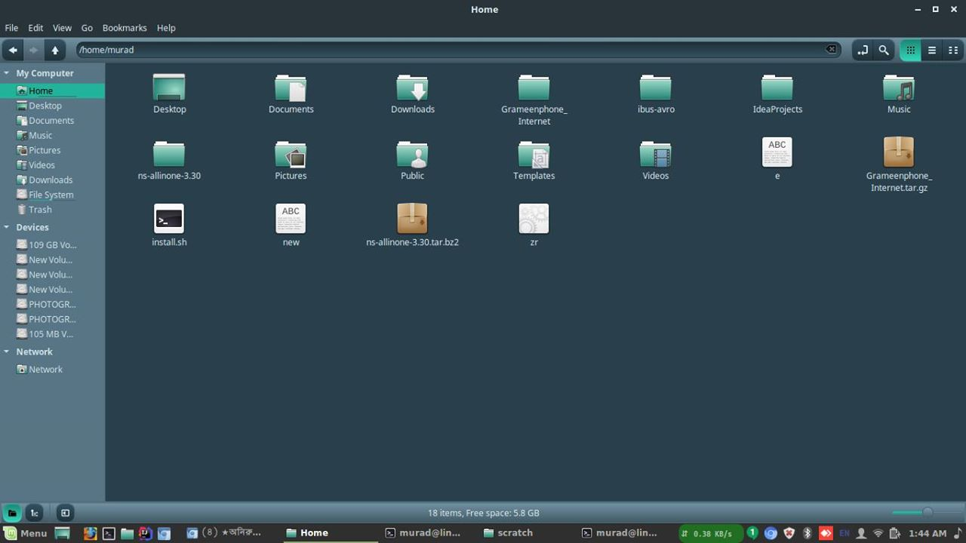

Home folder.. here the downloaded file must be put.

now, open Terminal (ctrl+Alt+T) & run the following commands:

echo $HOME

tar jxvf ns-allinone-3.30.tar.bz2

it will extract the ns3 folder ... now we have to run the commands..

cd ns-allinone-3.30/ns-3.30

./build.py --enable-examples --enable-test

it will take about 30 minutes... https://static.xx.fbcdn.net/images/emoji.php/v9/tce/1/18/1f642.png:) .. keep patience..

go to the folder.. home/ns-allinone-3.30/ns-3.30/examples/tutorial ..& copy the files..  
first.cc , first.py   
& paste them into.. /home/ns-allinone-3.30/ns-3.30/scratch .. folder.  
now, you are ready to run your fisrt lab code first.cc

**Step 3: Running first script( first Lab code):**

cd

cd ns-allinone-3.30/ns-3.30

run the .cc file:

./waf --run scratch/first

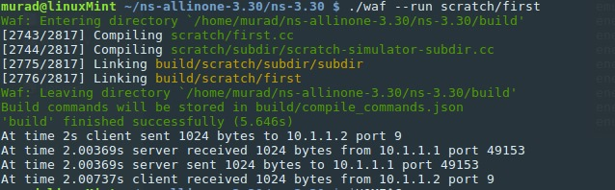

successfully running first.cc file

run the .py file:

./waf --pyrun scratch/first.py

**done.....................................**

if u face any problem..feel free to share screen live at.. google hangouts(wazidullahmurad@gmail.com) or use AnyDesk software (remote desktop software)